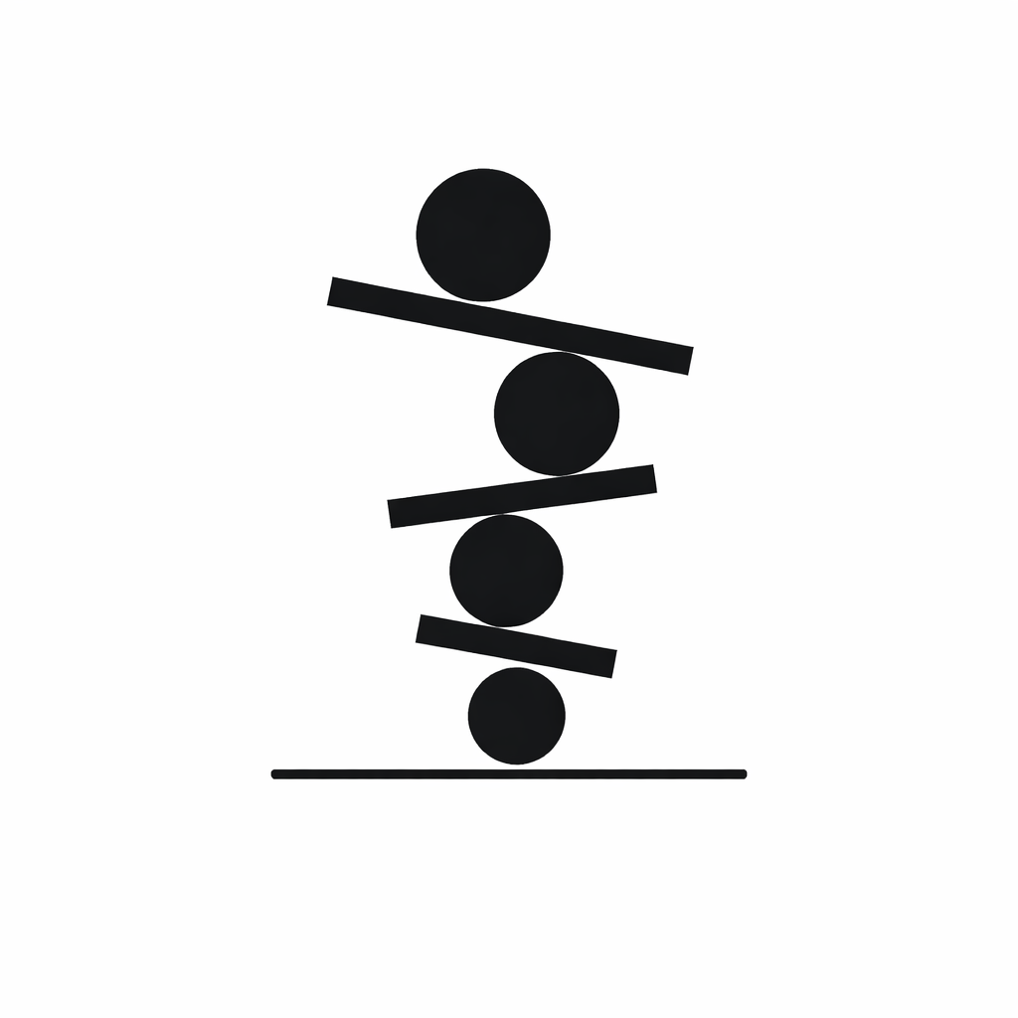

Usability Aspects Report
Unitas System
Version 1.0
Prepared by Limbo Software Development

Rodrigo Alejandro Hurtado Cortés - A01713854

Alexis Yaocalli Berthou Haas - A01713458

Ana Camila Cuevas González - A01412609

Alejandro Contreras Magallanes - A01662743

April 13th, 2026
Table of Contents

Usability Aspects Report - April 13th, 2026 3
Members of the UAR 3
1. UAR 1. Creation placeholder opacity: 3
2. Achievements and Highlights color implementation 4
3. Become activity dates into dropdowns 5
4. Change activity and role filters to sticky 5
5. Establish Account Administration pagination 6
6. Show colors depending on account status 7
7. Change ‘Employee’ on sidebar 8
8. Account name appearing in image slot if not image is provided 9
9. Make sidebar items sticky 10
10. Change account privilege colors in Roles Administration 11
11. Add description to Project Information 12
12. Eliminate all the AUTH privileges from Role Administration 13
13. Confirmation popup before removing employee or team from team and employee 14
14. Edit image in the upload of the account information 16
15. Division line in between the upload image and image name option 17
16. Correct visualization of the Projects in the Employee page 18
17. Move Delete buttons of project and team to the inner edit popup 18
18. Improvement of the Team Information 19
19. Team Lead not working in Team Directory (only own teams) 20
20. Employee not profile not being the on at the top Directory 22
21. Employee view not having style consistency with other modules 23
22. Improve Employee Information in Employee Page 24
Contexto de la prueba 26
Hallazgos de Usabilidad (UAR) 26
TA - Good 26
UAR 1. Flujo de perfil intuitivo 26
TA - Good 27
UAR 2. Edición de información clara 27
TA - Problem 27
UAR 3. Actividades equipo regresan hasta arriba 27
TA - Good 28
UAR 4. Eliminación de miembros con comportamiento cauteloso 28
TA - Good 28
UAR 5. Recuperación eficiente de usuarios 28
TA - Good 29
UAR 6. Creación de proyecto 29
TA - Good 29
UAR 7. Calendario bien diseñado 29
TA - Good 30
UAR 9. Agregar equipo poco intuitivo 30
Conclusión 30
Desempeño general del usuario 30
Fortalezas 30
Insight clave 30

Usability Aspects Report - April 13th, 2026

Members of the UAR
The presented Usability Aspects Report was obtained from the feedback of:
- Carlos Delgado Contreras
- Andrea Iliana Cantú Mayorga
- Professor Eduardo Daniel Juárez Pineda
- Ing. Bernardo Laing

During the following sections we will implement the scale of severity of IBM:
- 4 Catastrophic: The system causes a problem in the organization.
- 3 Severe: An important section of the system does not work correctly.
- 2 Minor: Small problem.
- 1 Flaw: Style defects.

Creation placeholder opacity:
HE - Problem
Description:
Currently the placeholders for the creation of Team and Project show a complete opacity of 1 (in a scale of 1-0), this causes confusion as if the already content needs to be deleted instead of simply typing over it.

Heuristica Violada: 8

Evidence:
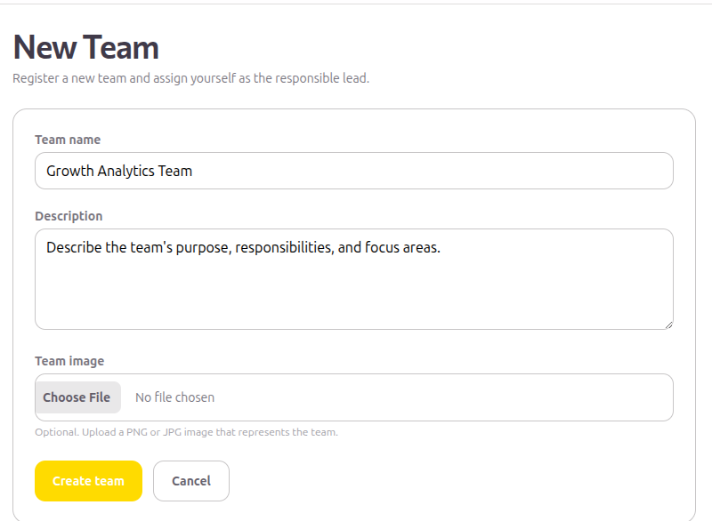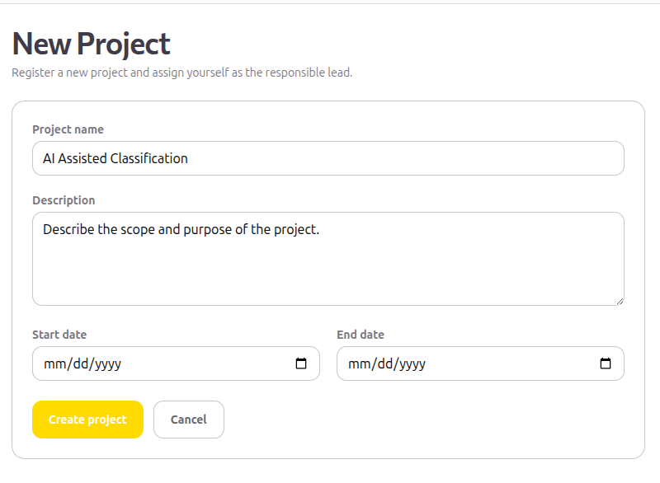

Problem Severity: 2 Small problems.

Proposed solution and considerations:
Add opacity to the placeholders of the creation forms.

FIX:

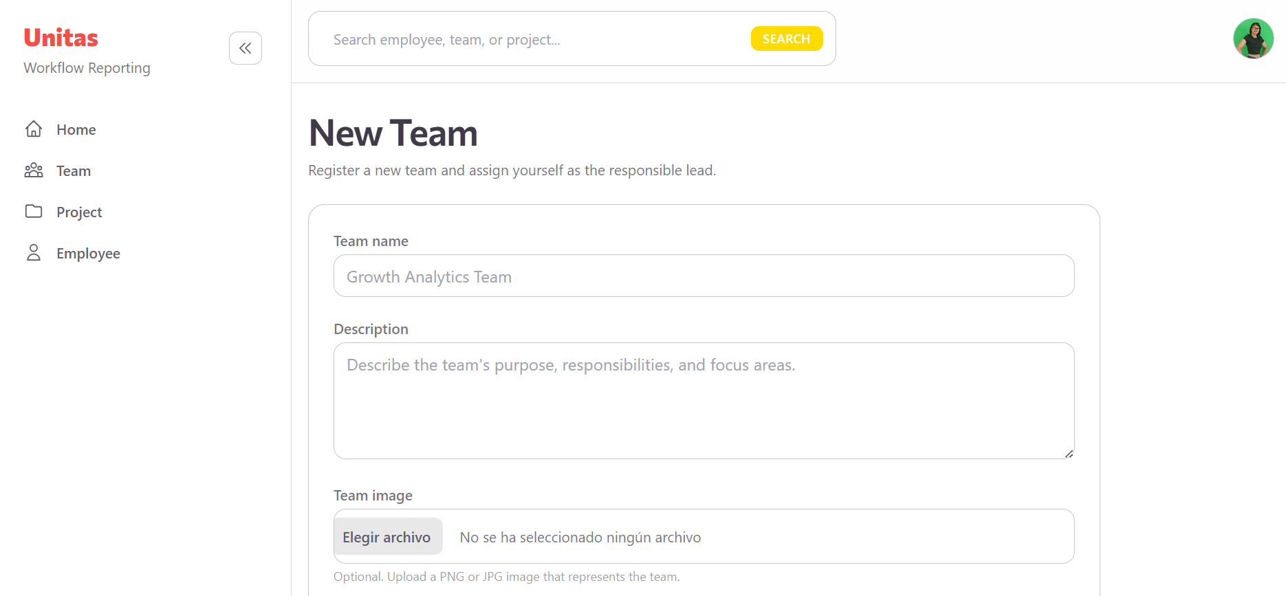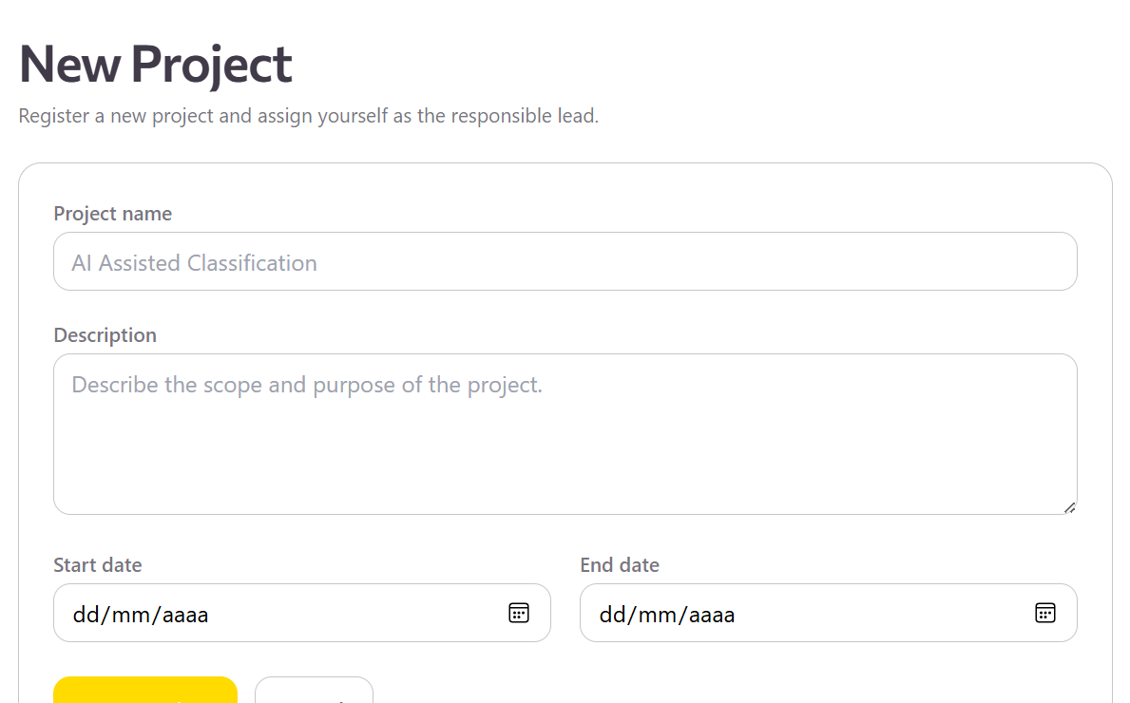

Achievements and Highlights color implementation
HE - Problem
Description:
Actually achievements and highlights keep the standard colors of the main interface (white and gray borders). With the consideration of the evaluator we might enhance both achievements and highlights with particular colors to show their importance and impact inside the project.

Heuristica Violada: 1, 8

Evidence:
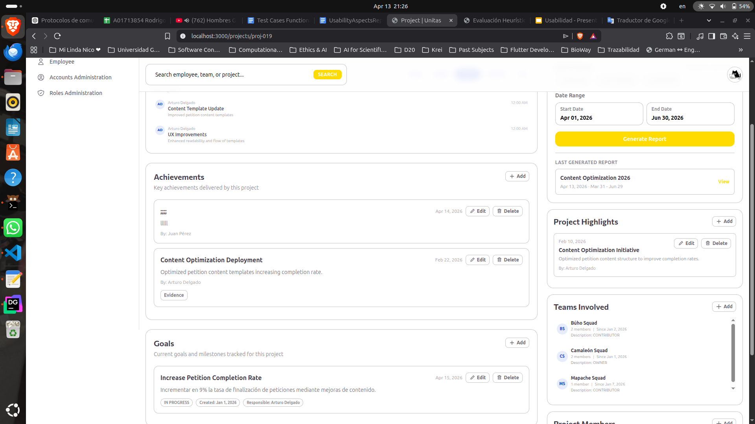

Problem Severity: 1 Flaw

Proposed solution and considerations:
Add slightly soft colors into the background of the cards or a remarkable border to both of them. Keep color palette consistent.

Become activity dates into dropdowns
HE - Problem
Description:
Currently the activities in the Employee page are classified by date, only divided by them. To increase efficiency while moving and searching for a concrete day or activity depending on our filters (Today, Week, Month, Quarter, All), each date can become a dropdown that reveals or capsules all the activities that occurred that day.

Heuristica Violada: 7, 6

Evidence:
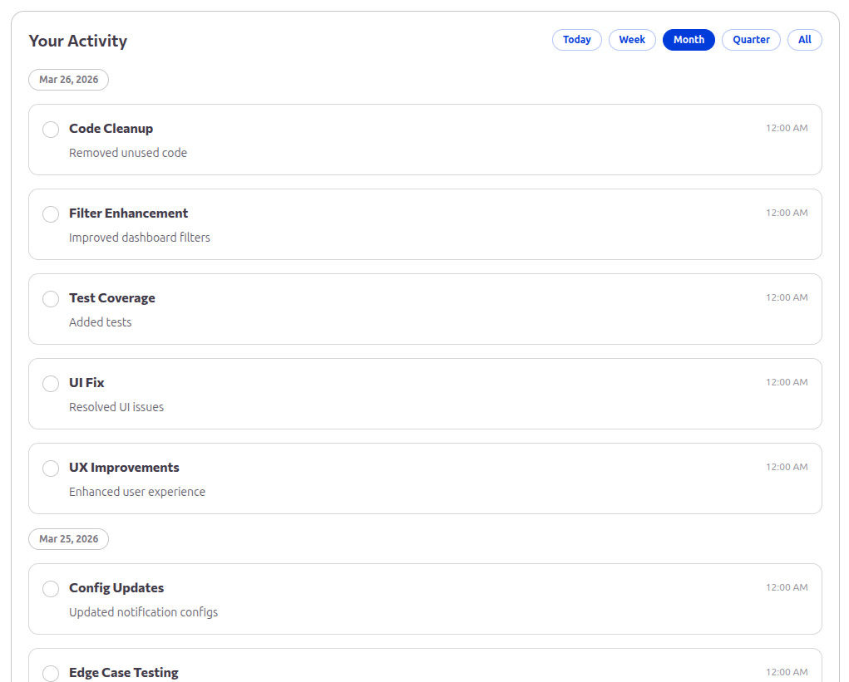

Problem Severity: 2 Minor

Proposed solution and considerations:
Make a modification in the activities section of the employee to make the date a dropdown that hides or shows the activities that occurred inside of it.

Change activity and role filters to sticky
HE - Problem
Description:
Currently, activity filters are shown at the top of the modal, but if going down in a very large modal the filters get lost at the top. To preserve the filters and accessibility, keep the filters as sticky even once the page has moved and preserve the ability to change the filters easily.

Heuristica Violada: 6, 7

Evidence:
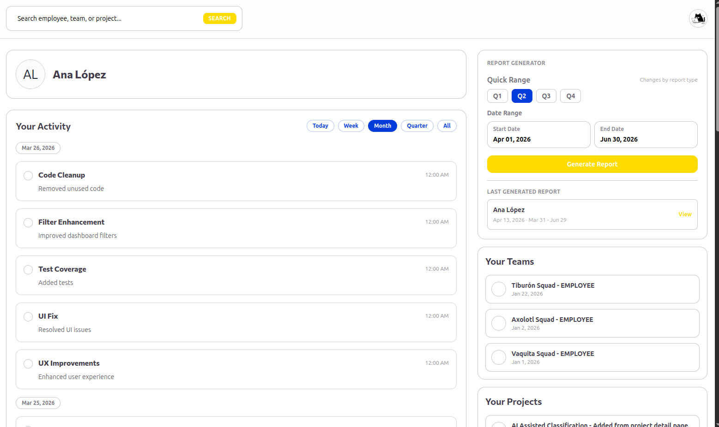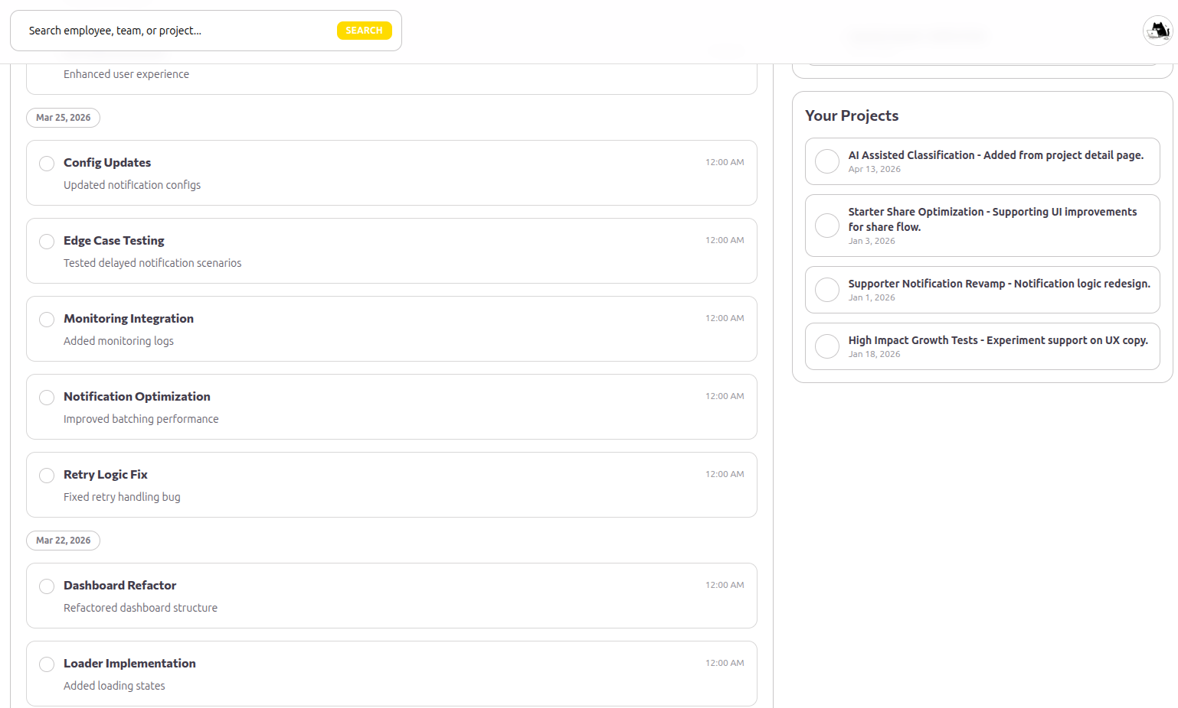

Problem Severity: 1 Flaw

Proposed solution and considerations:
Make the filters of the activity section in Employee sticky to the top of the screen.

Establish Account Administration pagination
HE - Problem
Description: Currently Accounts Administration shows all profiles, possibly making it hard to find an account in concrete.

Heuristica Violada: 7

Evidence:
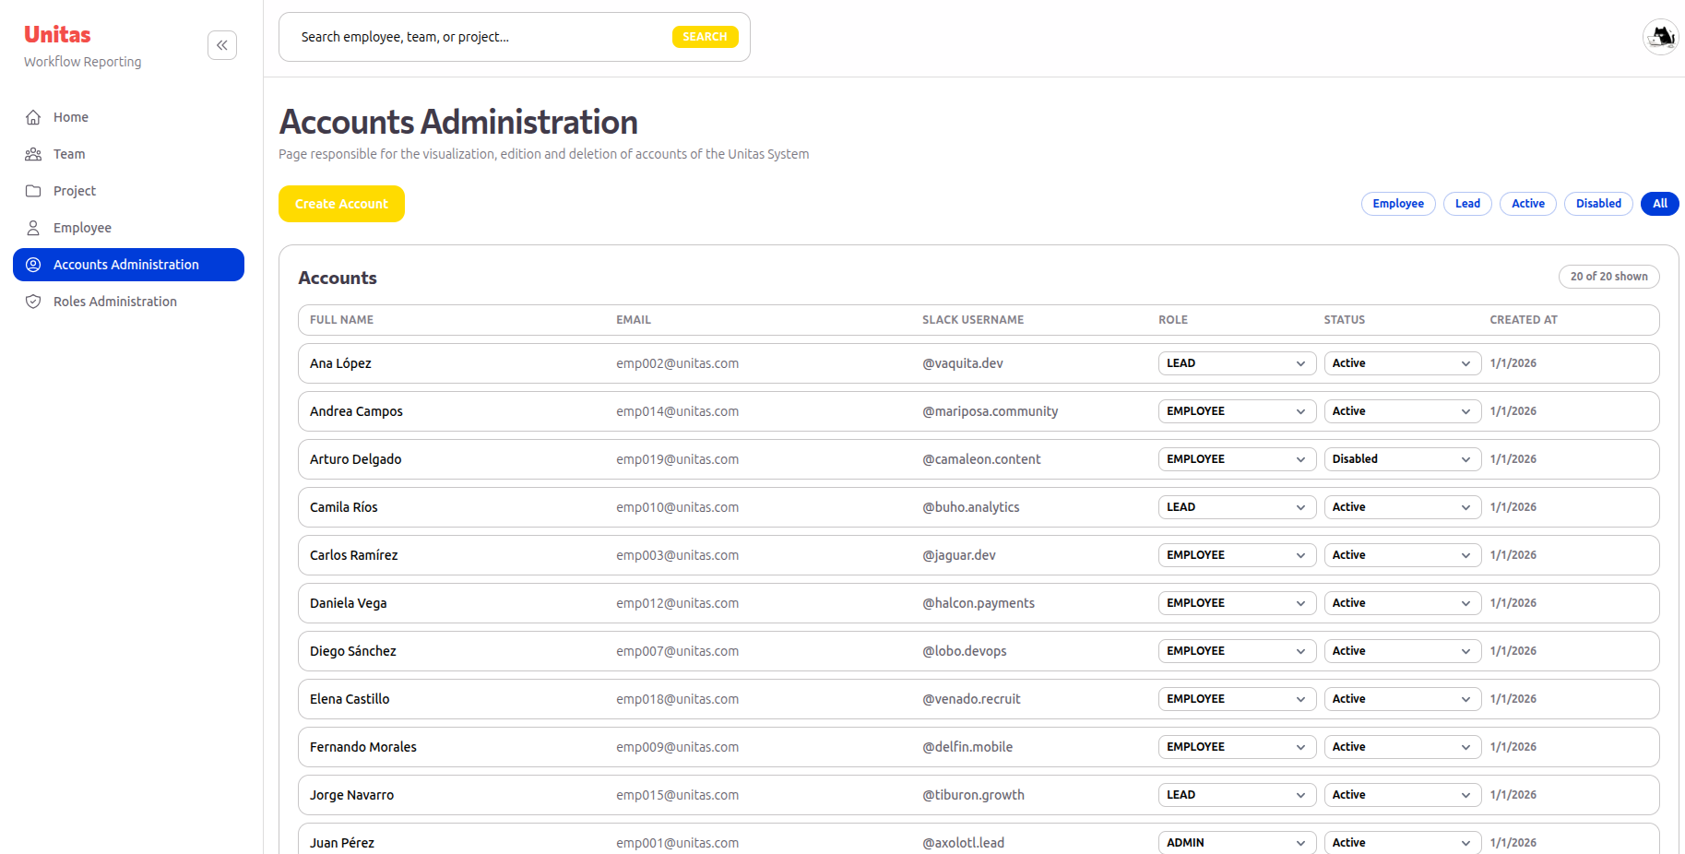

Problem Severity: 3 Major

Proposed solution and considerations:
Modify frontend to establish a pagination that allows to easily manage the number of accounts shown in the screen. Possibly establish a search bar to easily locate certain accounts.

Show colors depending on account status
HE - Problem
Description:
Currently in the actual Accounts Administration page, two status are available for accounts, ACTIVE and DISABLED, however they are not easily distinguished for any visual key that the text.

Heuristica Violada: 1

Evidence:
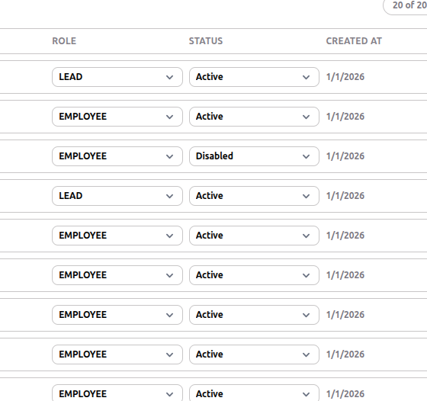

Problem Severity: 1 Flaw

Proposed solution and considerations:
Establish ACTIVE account status’ background with a slight green and DISABLED accounts status background with a slight red.

Change ‘Employee’ on sidebar
HE - Problem
Description:
Following client indications, the Employee section only shows the actual employee profile directly if the employee is not responsible or lead in any team or project. In this case the actual label of the section “Employee” might be confusing, therefore a change of label when the employee meets the previous characteristics is suggested.

Heuristica Violada: 2

Evidence:
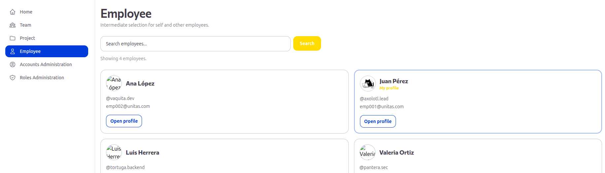
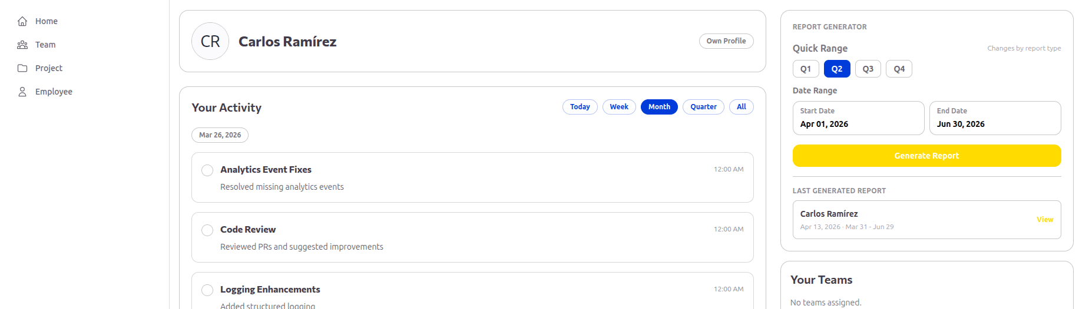

Problem Severity: 1 Flaw

Proposed solution and considerations:
Change the label of the section “Employee” dynamically depending if the employee is responsible for any Team or Project. Maybe change the name to “My employee profile”.

Account name appearing in image slot if not image is provided
HE - Problem
Description:
Currently the name of the account owner is shown instead of an image when there is no image for the account selected, this can be seen in the upper right section of any page.

Heuristica Violada: 4, 8

Evidence:
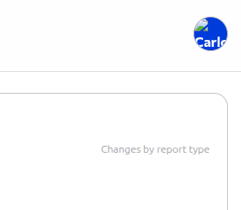

Problem Severity: 1 Flaw

Proposed solution and considerations:
Establish and use by default the API for the creation of Letter images instead of the direct name or a broken link.

Make sidebar items sticky
HE - Problem
Description:
Currently the sidebar elements can be lost if you scroll down in a very large page.

Heuristica Violada: 7

Evidence:
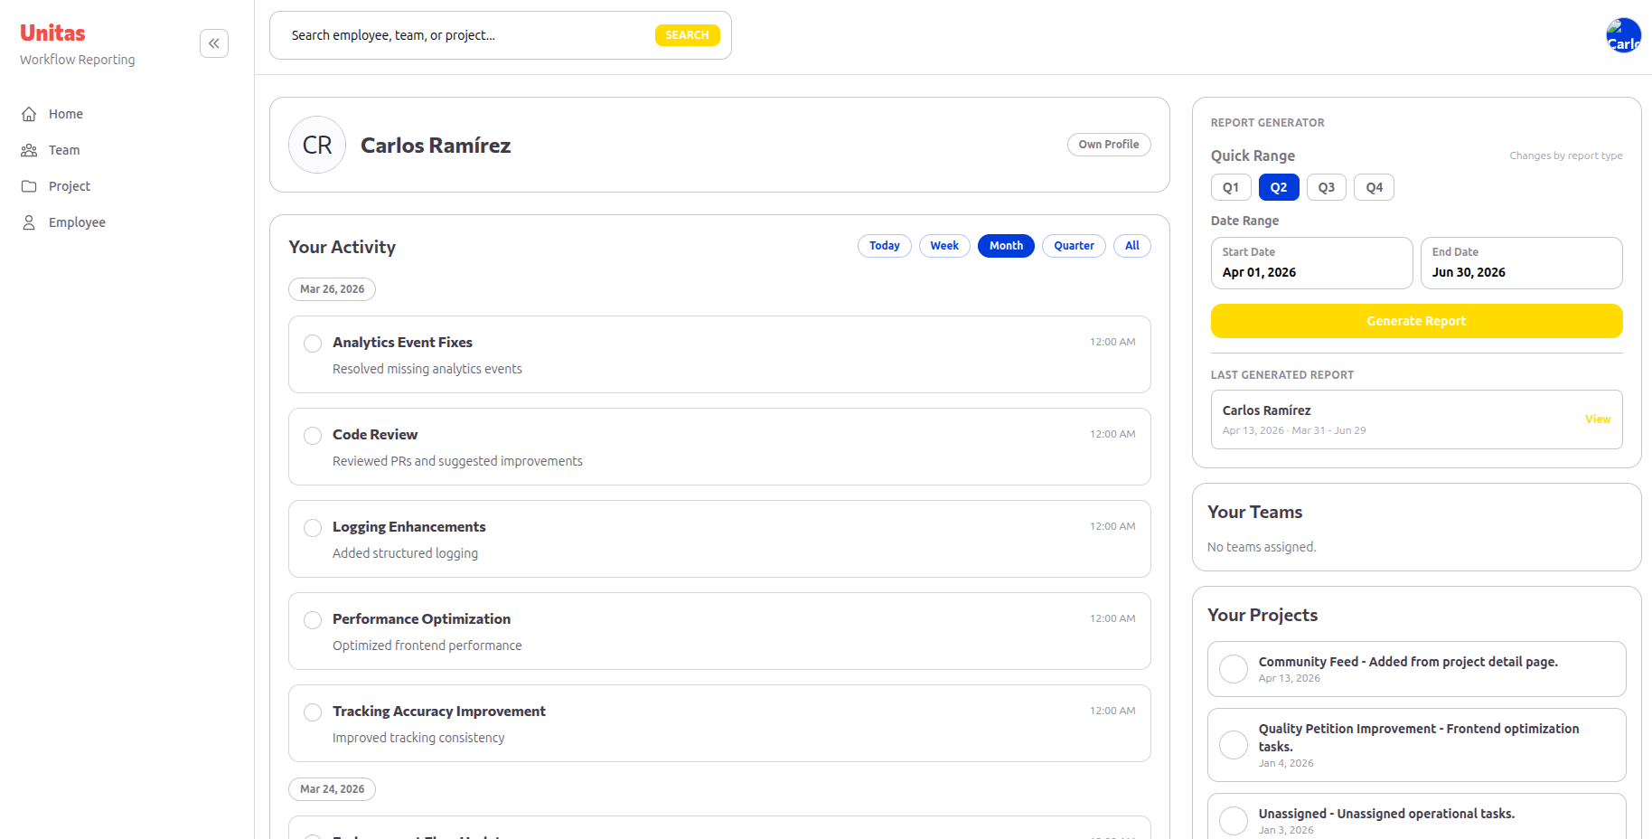
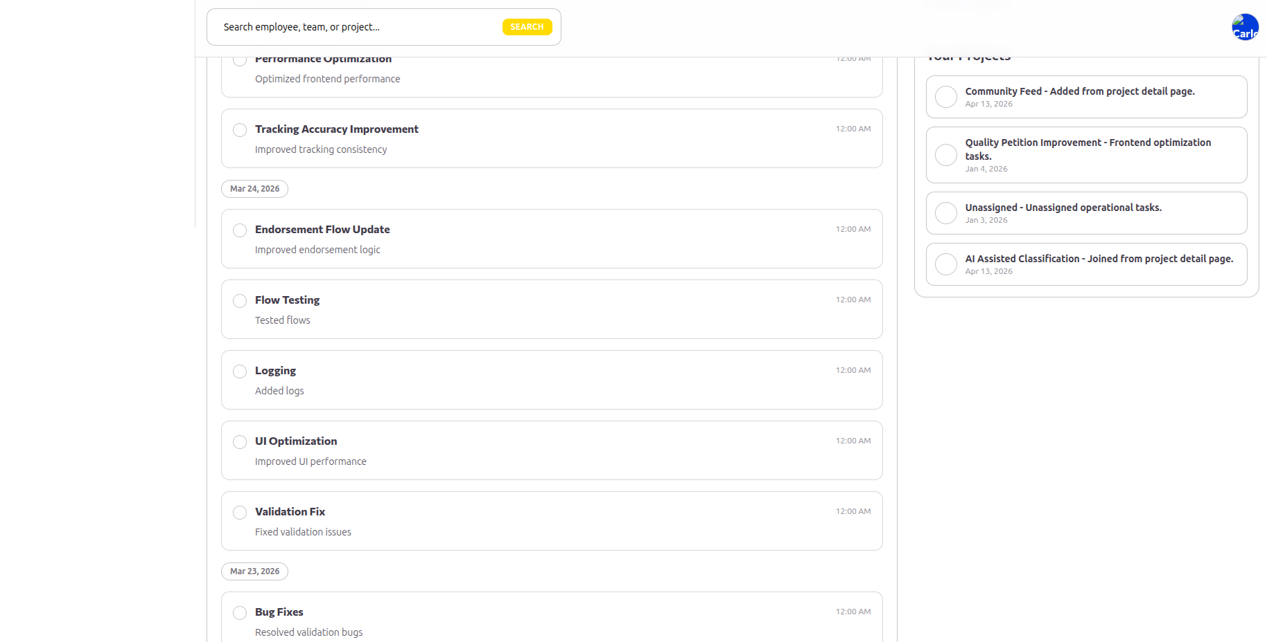

Problem Severity: 3 Severe

Proposed solution and considerations:
Make the elements of the sidebar sticky so they stay in user sight at all times. If a user needs to access the items and ends up needing to scroll through the screen to find them, they might become frustrated.

FIX:
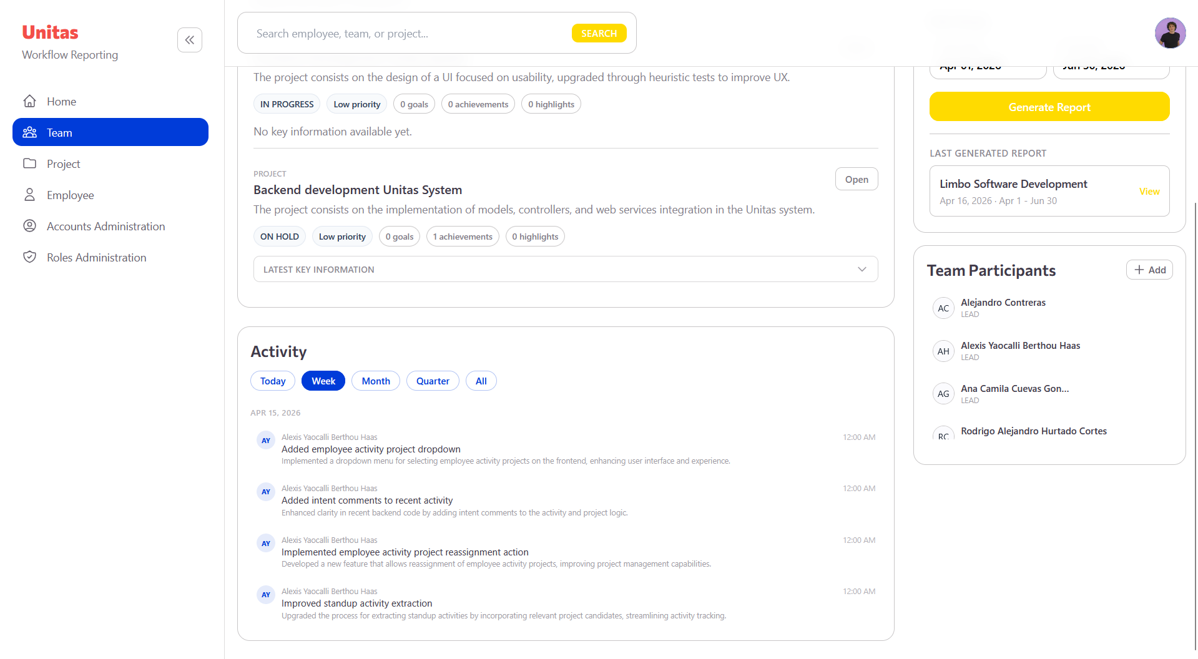

Change account privilege colors in Roles Administration
HE - Problem
Description:
Actually the section of Roles Administrations has toggles active or deactivated depending on the privileges of the selected role, all of these have the principal color Yellow, however for more than one evaluator, this color might become tiring after a while.

Heuristica Violada: 4, 8

Evidence:
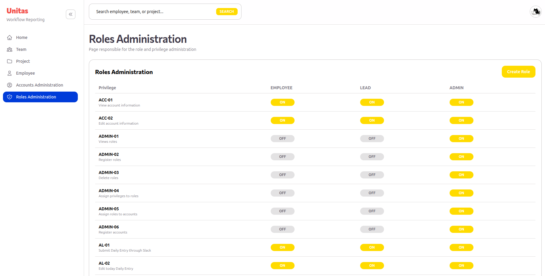

Problem Severity: 2 Minor

Proposed solution and considerations:
Change the toggle color to a different one: color offered by Camila and Alexis, use blue.

Add description to Project Information
HE - Problem
Description:
Currently the description of the Project is not being shown in any section of the project page, but rather part of the Project mentioned in other pages as Employee or Team.

Heuristica Violada: 6

Evidence:
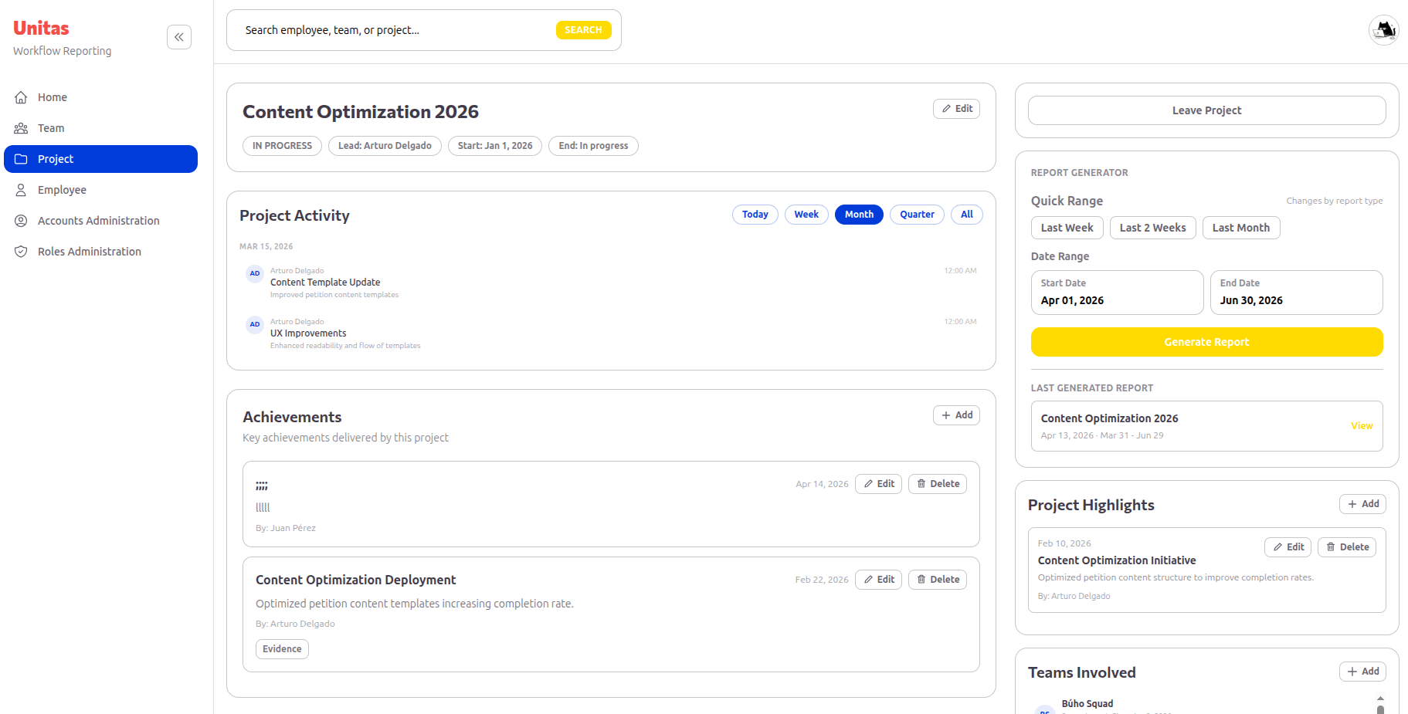

Problem Severity: 1 Flaw

Proposed solution and considerations:
Add the description into the Project Information section in the project page.

FIX:

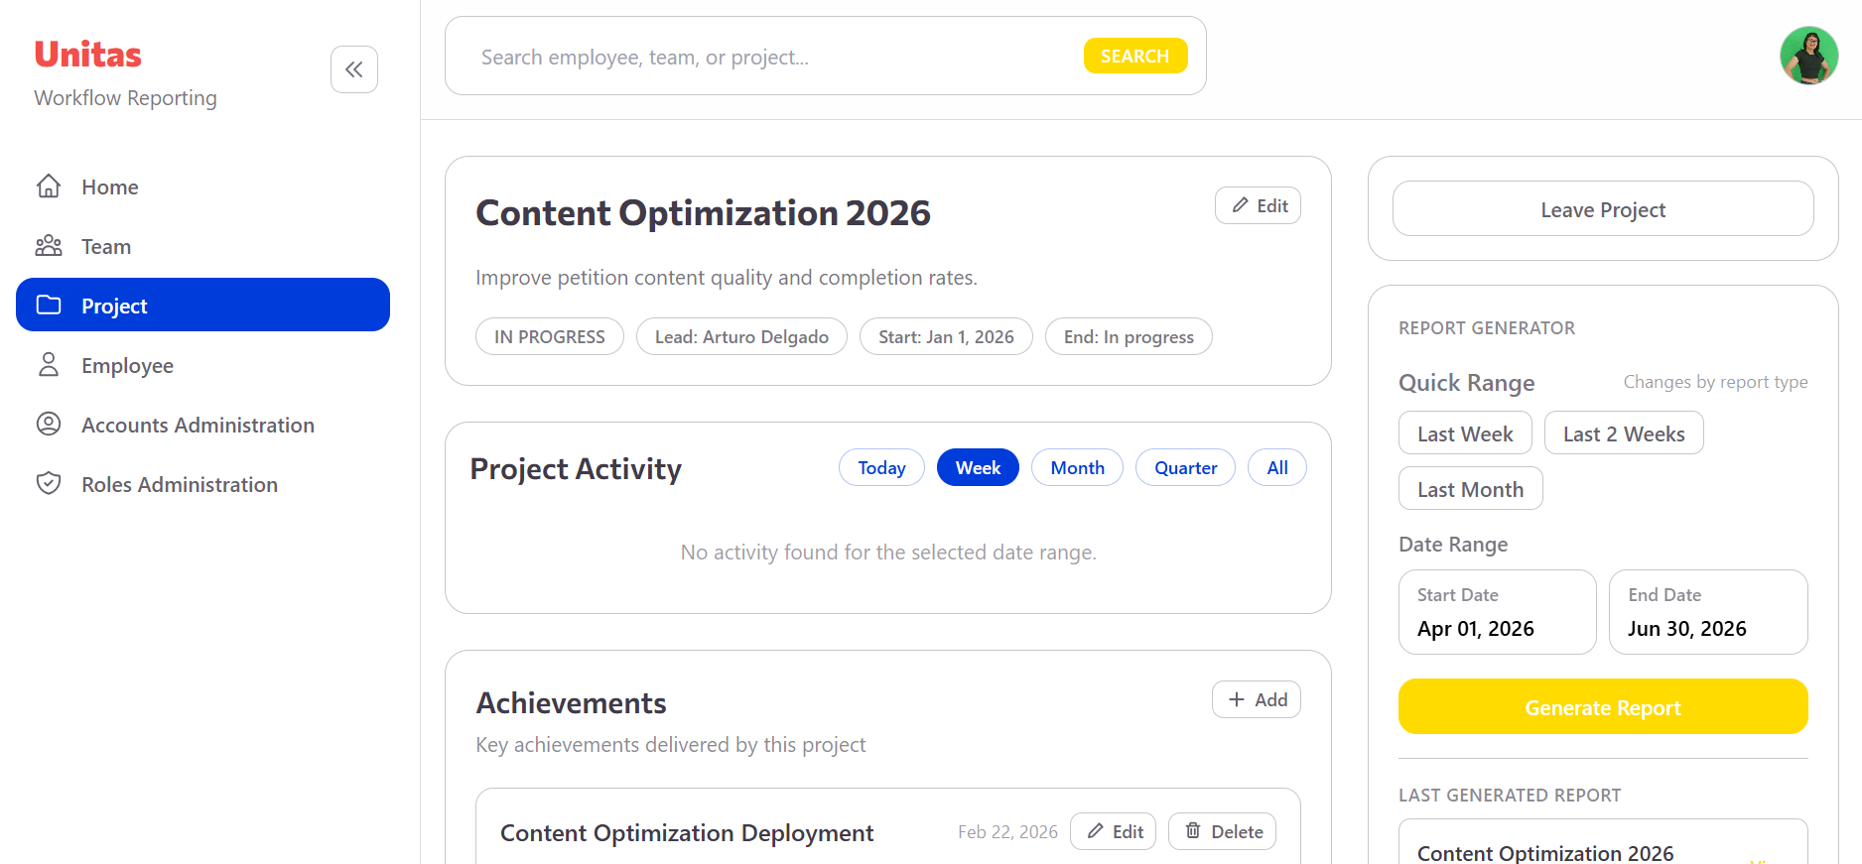

Eliminate all the AUTH privileges from Role Administration
HE - Problem
Description:
All AUTH privileges have no impact on the overall application and should be available for any account and therefore collection of accounts with common privileges (role), therefore this will always be part of every role and can not be deactivated.

Heuristica Violada: 5, 4

Evidence:
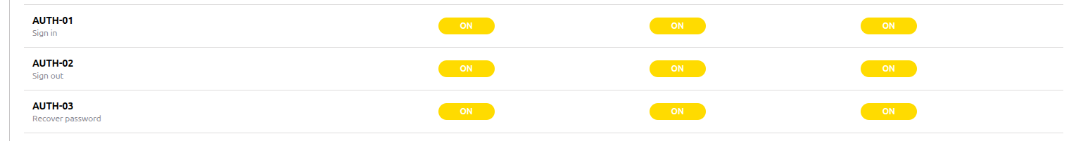

Problem Severity: 3 Major

Proposed solution and considerations:
Eliminate the AUTH privileges from the Role Administration view. Add always these privileges to any created role.

FIX:
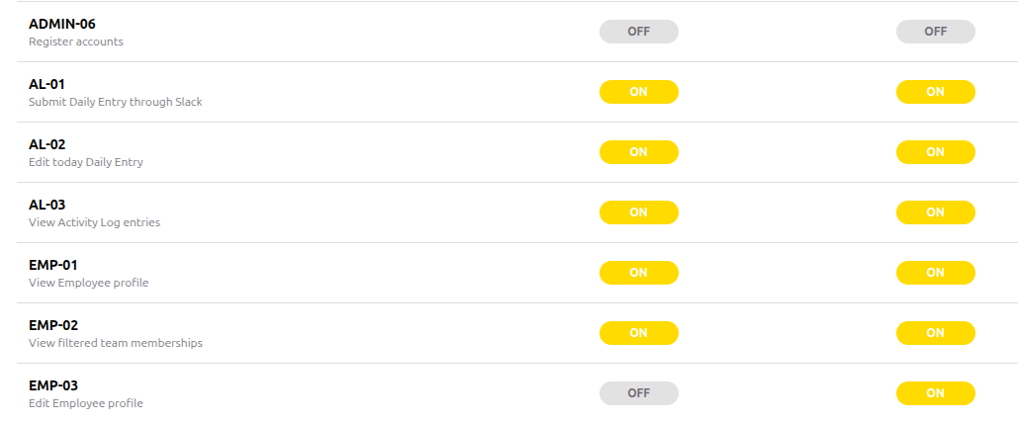

Confirmation popup before removing employee or team from team and employee
HE - Problem
Description:
Actually no confirmation popup is shown before the deletion of a member or team from a project , or employee from a team. This is required by description functionality.

Heuristica Violada: 3, 5

Evidence:

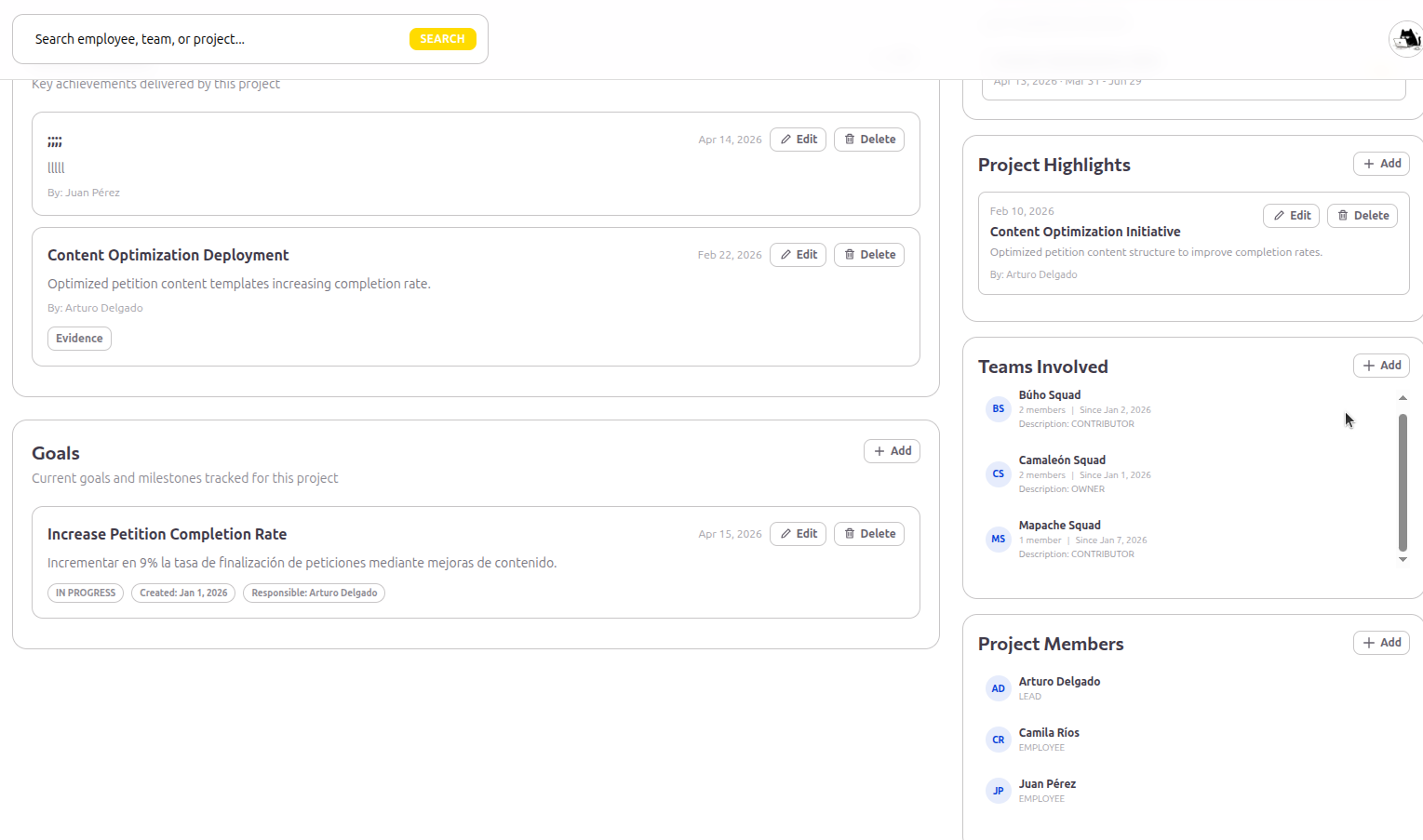
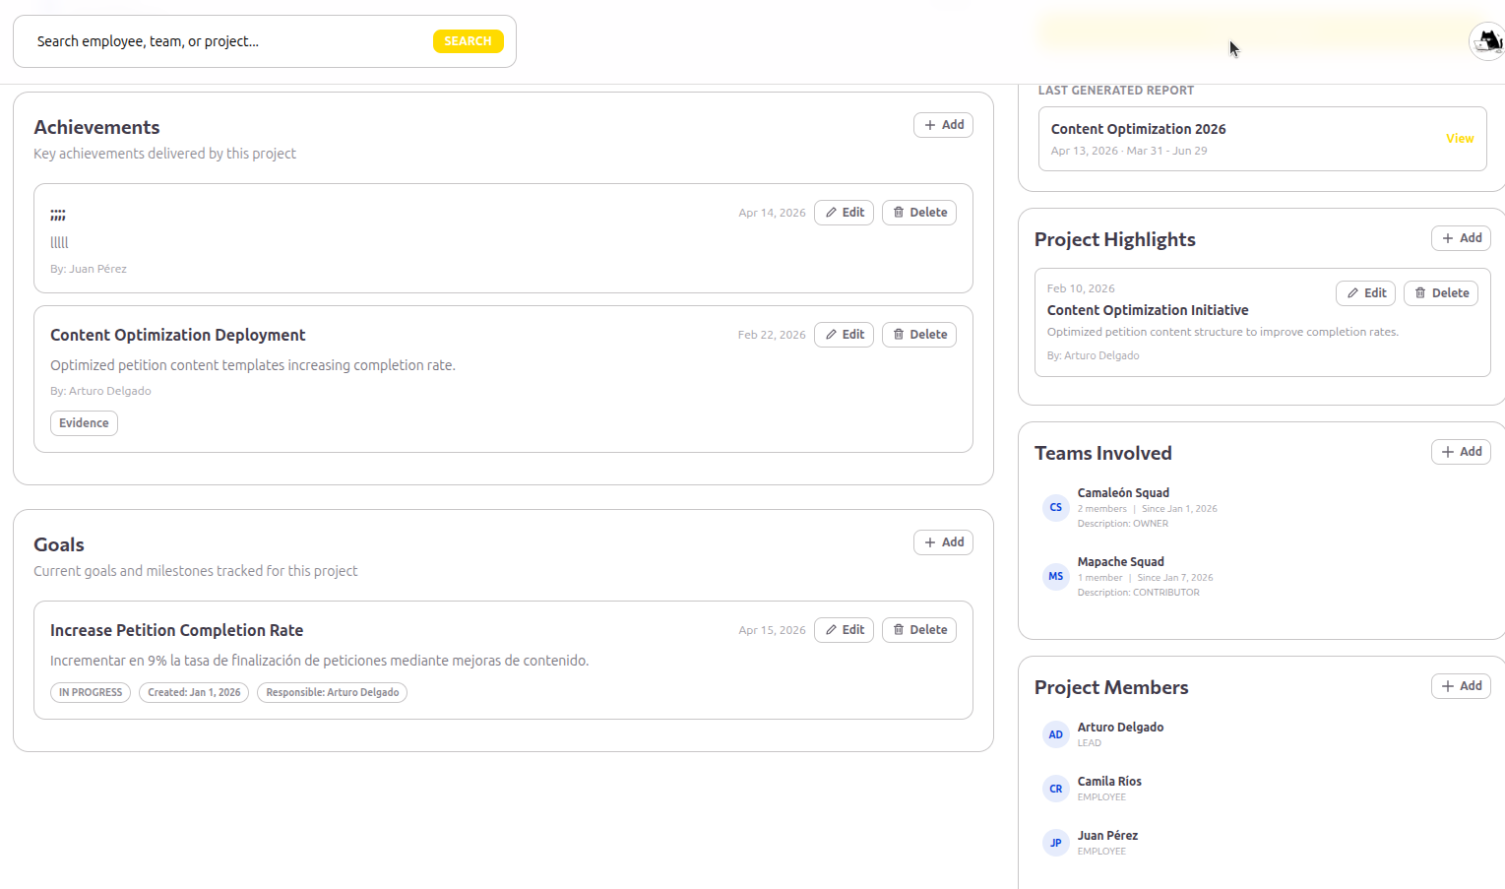

Problem Severity: 3 Major

Proposed solution and considerations:
Add a confirmation popup before eliminating any member or team from the project or team pages.

Edit image in the upload of the account information
HE - Problem
Description:
Currently the modification of the account image can only be done at the edit account information section. This is not intuitive at all, for it a new version is proposed.

Heuristica Violada: 10, 6

Evidence:
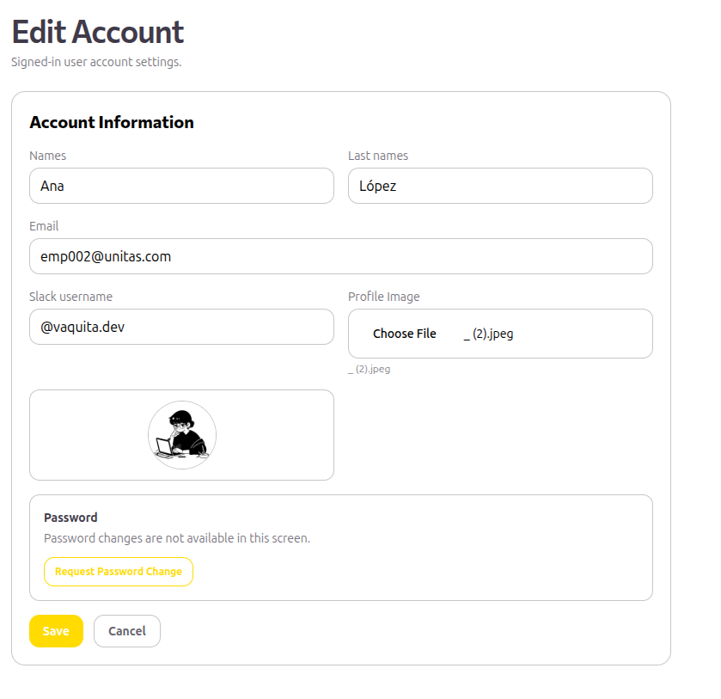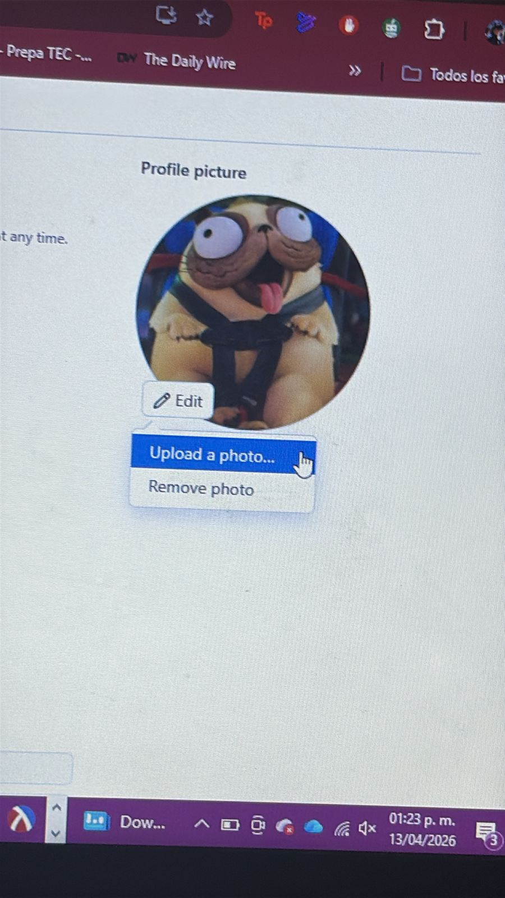

Problem Severity: 1 Flaw

Proposed solution and considerations:
Add the edit and delete image for the account directly into the visualization from any page and show the options as a dialog.

FIX:
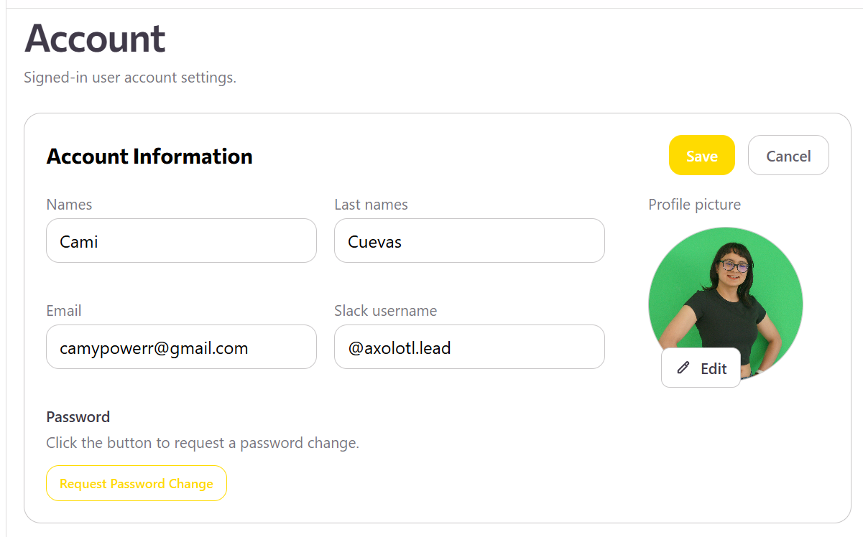

Division line in between the upload image and image name option
HE - Problem
Description:
There is no clear division between the button to upload an image in the account edition and the actual name of the uploaded image.

Heuristica Violada: 8

Evidence:
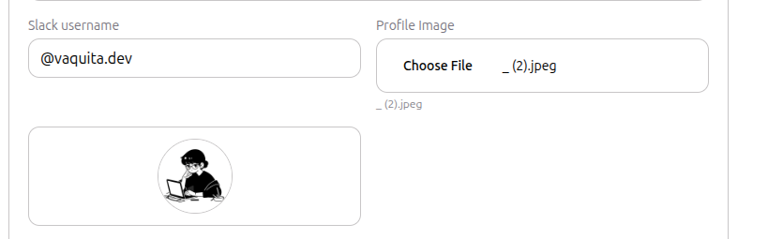

Problem Severity: 1 Flaw

Proposed solution and considerations:
Add a division line between these two elements.

FIX:
The proposed solution was not implemented because the chosen format was the one from the previous aspect.

Correct visualization of the Projects in the Employee page
HE - Problem
Description:
Currently projects are shown in the Employee page even after the Employee is not part of any project.
This is due to the aggregation of the status in the project relationship between the Employees and Projects. Check the query.

Heuristica Violada: 1, 5, 9

Evidence:

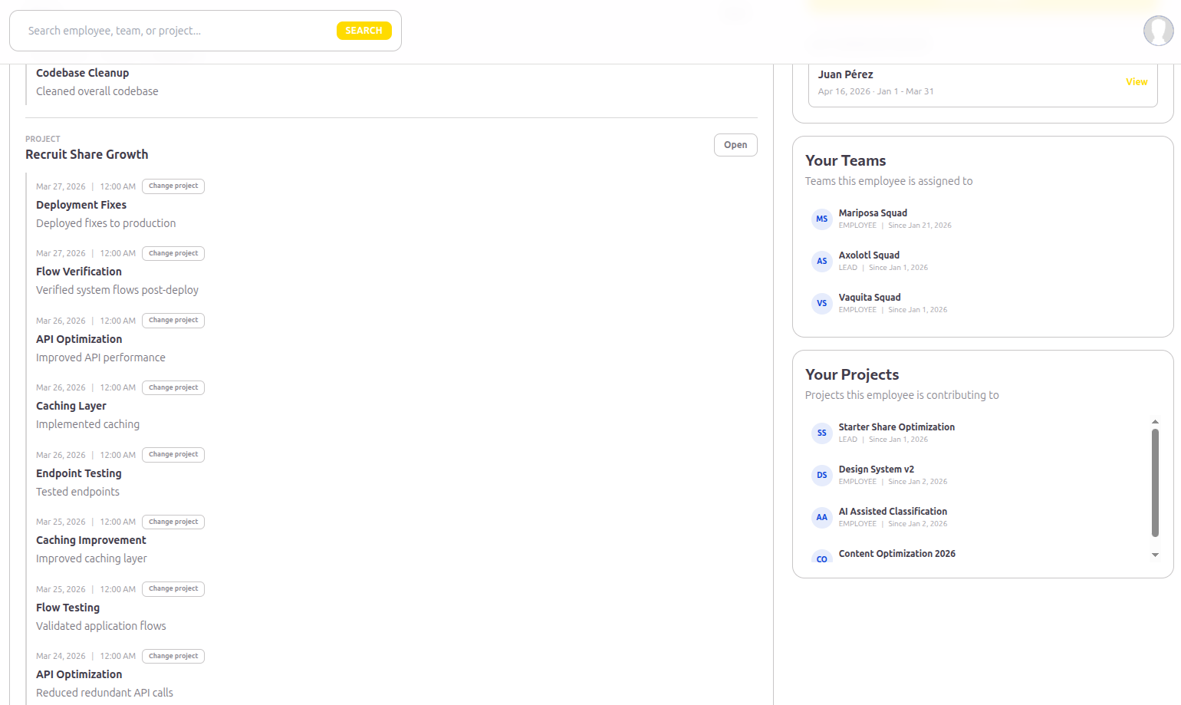
Problem Severity: 4 Catastrophic

Proposed solution and considerations:
Check the query that loads the projects of the employee.

Move Delete buttons of project and team to the inner edit popup
HE - Problem
Description:
The Delete project button is available at the end of the page at the bottom right corner. This is impractical and almost always foreseen. Moving this button to a more optimal location is required.

Heuristica Violada: 3

Evidence:
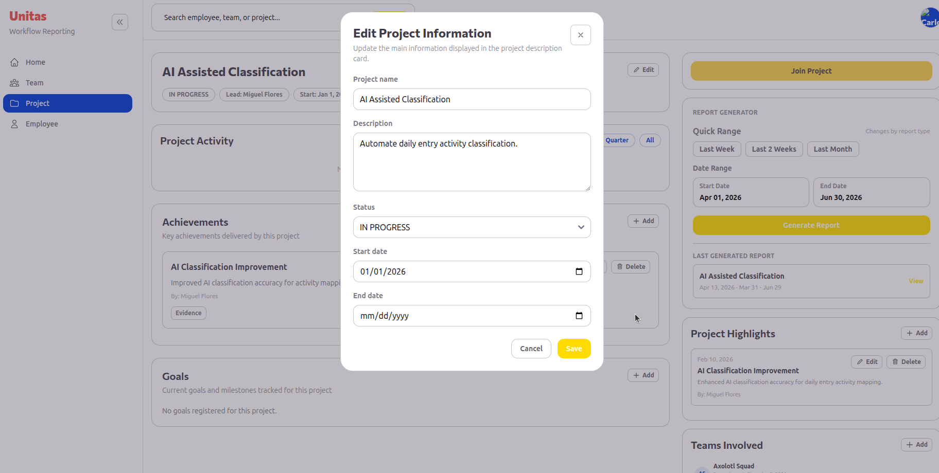

Problem Severity: 2 Minor

Proposed solution and considerations:
Move the delete button of both project and teams inside their edit popup.

Improvement of the Team Information
HE - Problem
Description:
Right now more information can be added to the Team Information section in the Team Page.

Heuristica Violada: 6

Evidence:
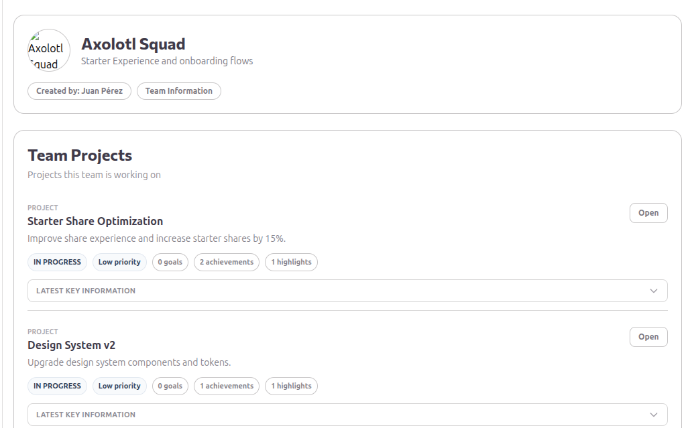

Problem Severity: 1 Low

Proposed Solution:
Add the created date at the team information. Eliminate the tag: “Team Information”

Team Lead not working in Team Directory (only own teams)
HE - Problem
Description:
Currently in the Team DIrectory, the label of Team Lead: “...” says “Pending Assignement” when the profile that created them should be the one who is responsible for them.

Heuristica Violada: 2, 5

Evidence:
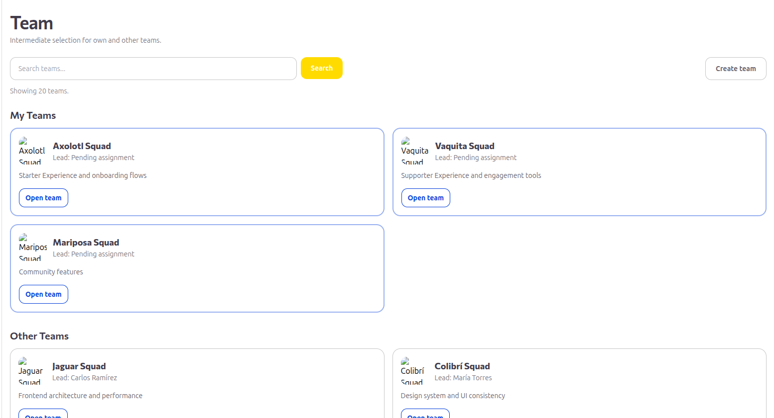

Problem Severity: 2 Minor

Proposed Solution:
Verify view for only own teams and compare to other teams how the manage the Team Lead association. Correct.

Employee not profile not being the on at the top Directory
HE - Problem
Description:
When entering the employee directory your profile isn't the first on the page.

Heuristica Violada: 7

Evidence:
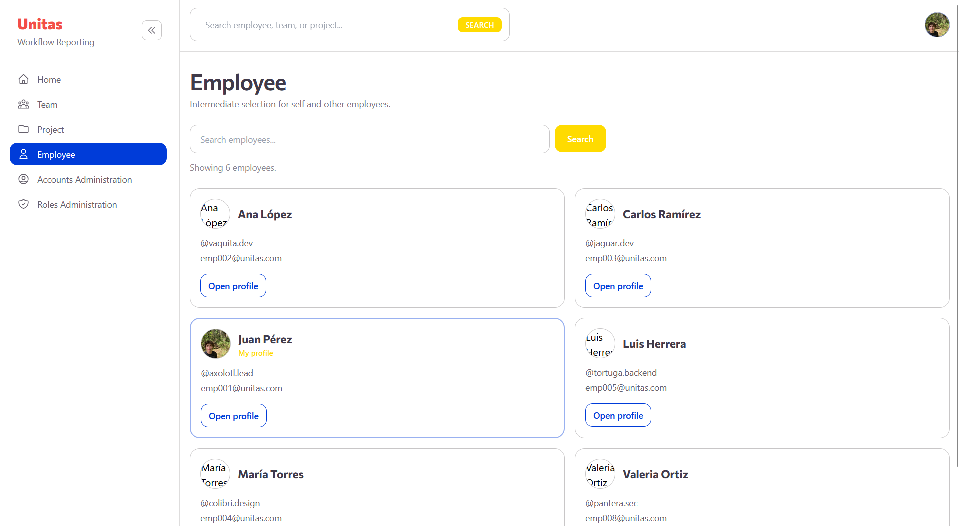

Problem Severity: 2 Minor

Proposed Solution and disadvantages if not treated:
Make the personal employee card show at the top, if the user has to search the card they might become frustrated.

FIX:
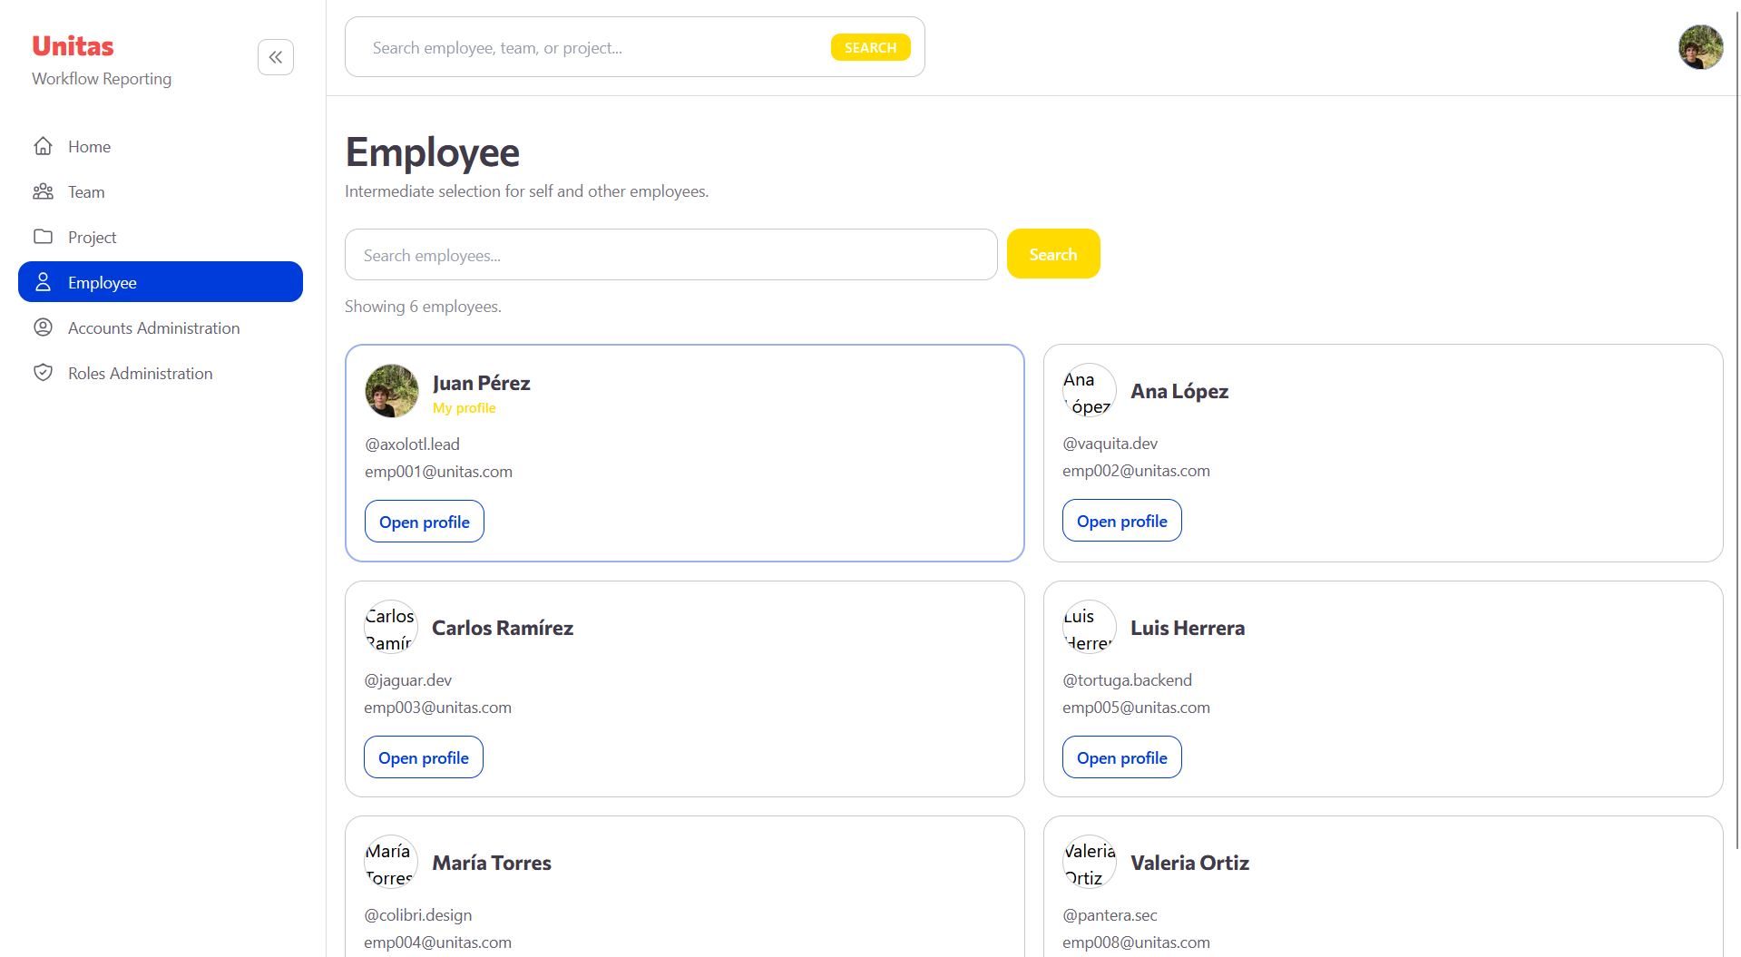

Employee view not having style consistency with other modules
HE - Problem
Description:
The employee view components for teams and projects don't have consistency with the rest of the views.

Heuristica Violada: 4

Evidence:
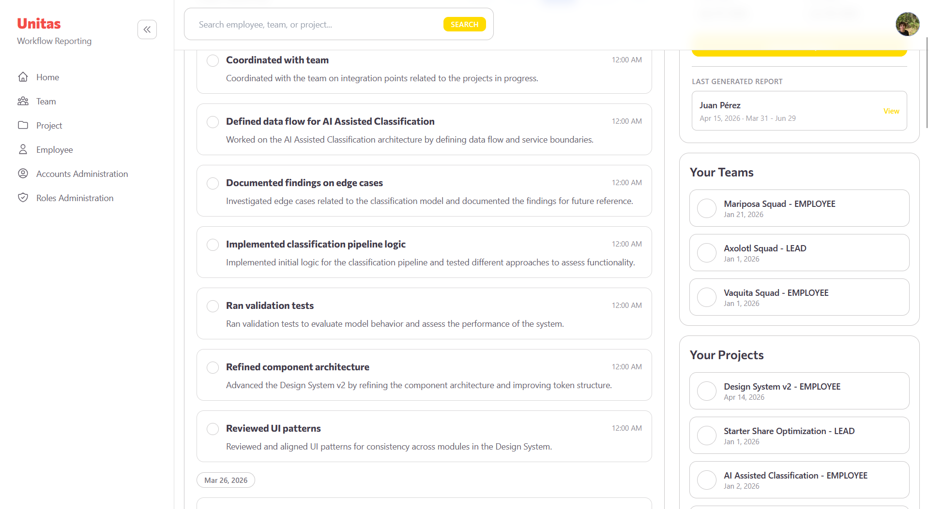

Problem Severity: 1 Flaw

Proposed Solution and disadvantages if not treated:
Change the style to fit the project and team view. Although it might not be important it is inconsistent and makes the product look bad.

FIX:
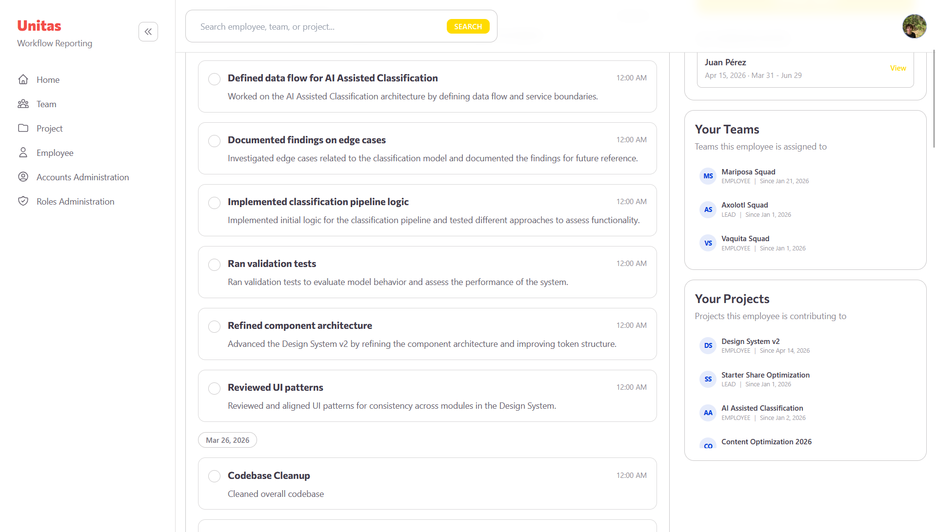

Improve Employee Information in Employee Page
HE - Problem
Description:
Currently the Employee information is only and exclusively its full name, leaving a very empty space that can be filled with additional data.

Heuristica Violada: 6

Evidence:
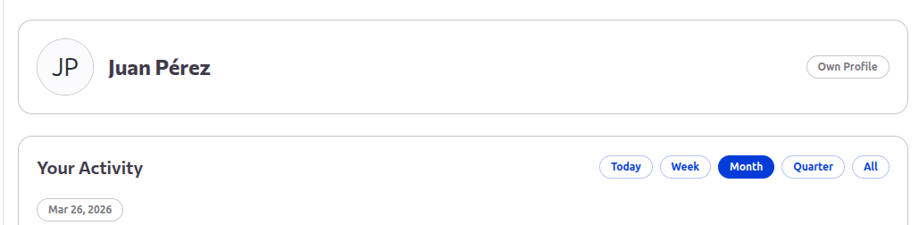

Problem Severity: 1 Flaw

Proposed solution:
Add to this section email and slack_username from the account. Modify query for this data obtention and possibly show the created date of the employee account.

FIX:
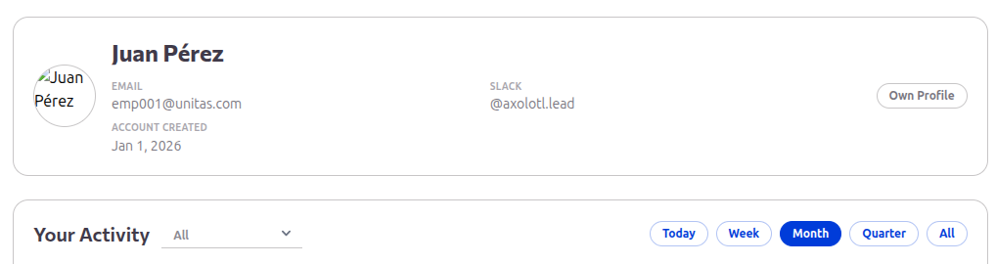

Privilege Toggles Color Unconsistent
TA - problem

Description:
The color of the toggles in the Role Administrator page is inconsistent after turning one on by rendering it off.

Broken Heuristic:

Evidence:
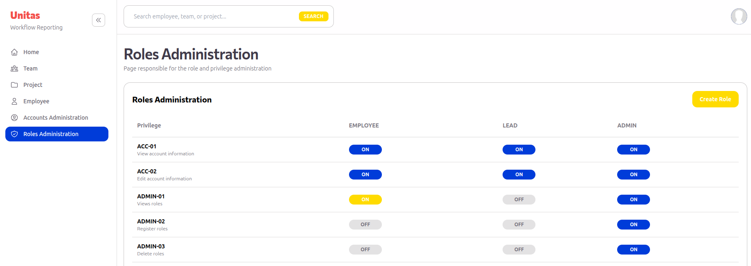

Problem Severity: 2 Minor

Proposed solution:
Check current code to update toggle switch to the new established color.

Account not easily found
TA - problem
Description:
For the edition of the account in the TA proof, it was not easily shown, a different name for the upper section is proposed “Edit Account”.

Broken heuristic:

Evidence:
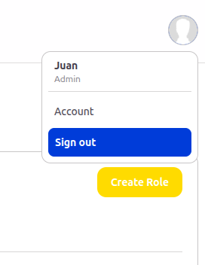

Problem severity: 1 Flaw

Proposed solution:
Change the name “Account” to “Edit Account”

Generate Report Notification
TA - problem
Description:
The report of a section was generated, yet the user didn’t notice. A more visible notification for the completion of the generation is required.

Broken Heuristics:

Evidence:
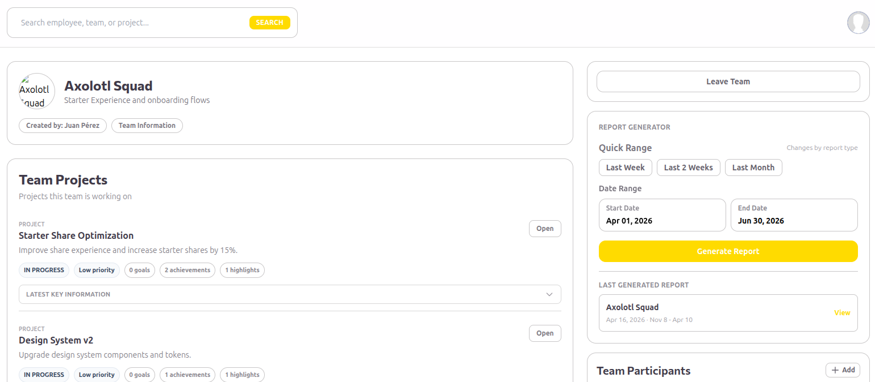

Problem severity: 2 Minor

Proposed solution:
Create a flash notification for the completion of the report generation.

- Eliminate AUTHENTICATION label in Login
- Pair search button sizes
- Agregar espacio en chosen file - Create Team
- Change my profile color on Employee Directory

Prueba Think Aloud
Usuario: Luis Alfredo
Duración total: ~8 minutos
Método: Think Aloud (verbalización continua)
Objetivo: Evaluar la facilidad de uso del sistema en tareas clave relacionadas con perfil, equipos y proyectos.

Contexto de la prueba
Durante la sesión, el usuario fue guiado para realizar una serie de tareas dentro del sistema, incluyendo:
- Acceder y editar información de perfil
- Navegar entre módulos (Team y Project)
- Consultar actividades
- Gestionar miembros de equipo
- Crear un proyecto
- Agregar un equipo a un proyecto
El usuario verbaliza constantemente su proceso de pensamiento, lo que permitió identificar tanto su comprensión del sistema como sus dudas, interpretaciones y decisiones.

Hallazgos de Usabilidad (UAR)

TA - Good

UAR 1. Flujo de perfil intuitivo
Acción solicitada: Ver la información de la cuenta (perfil)
Heurísticas cumplidas:
- Correspondencia entre el sistema y el mundo real
- Consistencia y estándares
Evidencia:
“En la esquina superior derecha está tu foto de perfil…” (0:21)
Tiempo: ~6 segundos
Evaluación de desempeño:
El usuario localizó su perfil de manera inmediata y sin errores.
Conclusión:
Tarea completada de forma rápida y eficiente.

TA - Good

UAR 2. Edición de información clara
Acción solicitada: Editar el apellido del perfil
Heurísticas cumplidas:
- Visibilidad y estatus del sistema
- Reconocimiento antes que recuerdo
Evidencia:
“Pues bastante fácil…” (0:59)
Tiempo: ~35 segundos
Evaluación de desempeño:
El usuario editó la información correctamente sin necesidad de ayuda ni intentos fallidos.
Conclusión:
Flujo claro, directo y bien comprendido.

TA - Problem

UAR 3. Actividades equipo regresan hasta arriba
Acción solicitada: Ver las actividades realizadas por el equipo
Heurísticas violadas:
- Correspondencia entre el sistema y el mundo real
- Consistencia y estándares
Evidencia:
“Supongo que las puedo filtrar…” (3:22)
Tiempo de decisión: ~10 segundos
Evaluación de desempeño:
El usuario logró completar la tarea pero con cierto disgusto por la conclusion.
Problema:
Después de aplicar un filtro regresa hasta el principio.
Conclusión:
Tarea completada con fricción leve.
Solución propuesta:
- Convertir componente a AJAX

TA - Good

UAR 4. Eliminación de miembros con comportamiento cauteloso
Acción solicitada: Eliminar un miembro del equipo
Heurísticas cumplidas:
- Prevención de errores
- Control y libertad del usuario
Evidencia:
“No, no lo quiero sacar o si lo saco…” (4:39)
Evaluación de desempeño:
El usuario comprendió la acción y decidió con cautela antes de ejecutarla.
Conclusión:
Interacción clara y correctamente interpretada.

TA - Good

UAR 5. Recuperación eficiente de usuarios
Acción solicitada: Volver a agregar un miembro al equipo
Heurísticas cumplidas:
- Flexibilidad y eficiencia de uso
Evidencia:
“Está súper bien porque podría buscar…” (5:00)
Evaluación de desempeño:
El usuario identificó rápidamente cómo completar la tarea.
Conclusión:
Flujo eficiente y bien diseñado.

TA - Good

UAR 6. Creación de proyecto
Acción solicitada: Crear un nuevo proyecto
Evidencia:
“Vamos a ponerle… qué poner…” (6:32)
Tiempo: ~1 min
Evaluación de desempeño:
El usuario completó la tarea correctamente, pero dudo en el campo de descripción.
Conclusión:
Tarea completada.

TA - Good

UAR 7. Calendario bien diseñado
Acción solicitada: Seleccionar fechas durante la creación de un proyecto
Heurísticas cumplidas:
- Reconocimiento antes que recuerdo
- Visibilidad y estatus del sistema
Evidencia:
“Está muy bien que…” (6:21)
Evaluación de desempeño:
El usuario utilizó correctamente el calendario sin dudas y agradeció el hecho de que estuviera el calendario.
Conclusión:
Interacción fluida, con un gran agrado a esta funcionalidad.

TA - Good

UAR 9. Agregar equipo poco intuitivo
Acción solicitada: Agregar un equipo a un proyecto
Evidencia:
“Supongo que es en el apartado…” (7:10)
Tiempo: ~30 segundos
Evaluación de desempeño:
El usuario logró completar la tarea, pero tardó en encontrar la funcionalidad.
Problema:
Falto contextualizacion con la acción durante la prueba
Conclusión:
Tarea completada con cierta fricción.

Conclusión

Desempeño general del usuario
El usuario logró completar todas las tareas solicitadas sin errores críticos. Sin embargo:
- Varias acciones requirieron inferencias
- Algunas funcionalidades no fueron inmediatamente visibles
- Existieron momentos de duda no relacionados con fallas del sistema

Fortalezas
- Navegación intuitiva en tareas básicas
- Uso correcto de estándares UI
- Buen feedback del sistema
- Elementos bien diseñados como el calendario

Insight clave
El sistema funciona acorde a lo que el usuario asume que funcionaria.

